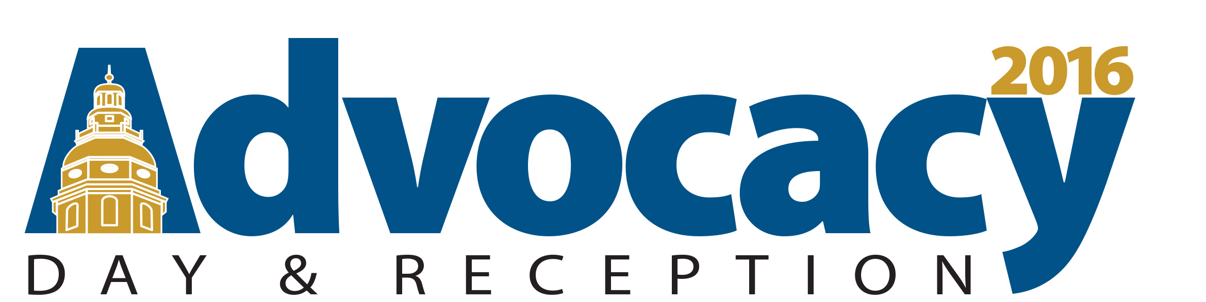

Policy One Pager: House Bill 155/Senate Bill 278
Criminal Law - Stalking and Harassment

What is the issue?
The U.S. Bureau of Justice Statistics performed a 12-month study to analyze the prevalence of stalking and harassment across the nation. According to the study, those who were at the highest risk of stalking and harassment were divorced or separated individuals being targeted by their former spouses. In Maryland, these victims often go unprotected because gaps in the current law. Right now in Maryland, a victim can be texted 100 times a day or called repeatedly on their work phone with no relief, so long as conduct is not explicitly “malicious” in nature. This not only impacts the mental health of the victim but also their jobs and family life. More than half of the victims studied missed 5 or more days of work due to this emotionally disturbing communication.
What can be done?
House Bill 155/Senate Bill 278 would prohibit persons from engaging in crimes related to stalking, harassment and misuse of electronic devices, even if the acts are not explicitly malicious in nature, so long as the perpetrator intends to cause serious emotional distress to another. With the ever-expanding use of electronic devices for communication, it has become more difficult for victims of stalking and harassment to escape the harmful reach of their abusers.
How would this impact the Jewish community?
Prevention and treatment of domestic violence is a priority for the Jewish community. The Baltimore Jewish Council advocates on behalf of CHANA, an agency of the Associated. For over 20 years, CHANA has provided crisis intervention to victims of physical, financial and emotional abuse in the greater Baltimore area. Last year Washington’s Jewish Coalition against Domestic Abuse provided 137 victims of domestic abuse free clinical services including individual and group therapy, financial planning and case management.
The rapid increase in electronic communication as a means to harass and stalk victims has made it extremely difficult to provide relief to these clients under the current legislation. Harassment and stalking are often used in conjunction with the types of abuse listed above, intimidating and isolating victims as a part of a dangerous power dynamic. Since electronic communication has no physical boundaries, this not only affects the home lives of victims but their productivity and attendance in the workplace as well. A change in the law through HB155/SB278 would allow victims the necessary relief they require to live their lives free from fear and intimidation.
What can we do today?
Tell your legislator that you support House Bill 155 and Senate Bill 278!

