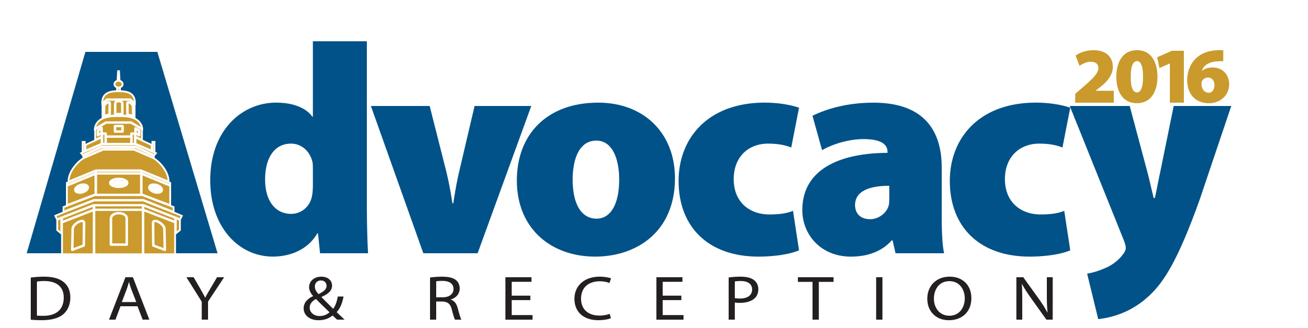

Budget One Pager

Every year, the Baltimore Jewish Council advocates in Annapolis to create and maintain funding for several Jewish community projects. This year ALL of the requests made by the Baltimore Jewish Council were included in the Governor’s budget. This is great news! Now, you can help protect this funding by speaking with your representatives about the importance of these various programs.
What programs are being funded?
- $2,000,000 – Community Primary & Specialty Care Complex at Sinai
  - This health complex will reduce preventable emergency room visits by providing wraparound services for the local community, including specialty and subspecialty care typically unavailable in this neighborhood.
- $575,000 – Aging-in-Place & Holocaust Survivor Funds
  - The Supportive Community Network helps Northwest Baltimore residents organize neighborhood-based cohorts of older adults working together to support each other’s needs and interests. Funding is also requested in the budget to cover the rising costs for Holocaust survivors to age-in-place.
- $275,000 - Maryland-Israel Development Center (MIDC)
  - MIDC is a non-profit economic development organization that promotes job creation by facilitating bilateral trade and investment between Maryland and Israel. Recently MIDC brought ELTA, the 4th largest radar manufacturer in the world, to headquarter in Maryland, creating approximately 100 jobs.
- $250,000 – Sinai Diabetes Medical Home Extender Program
  - This program allows uninsured and underinsured community residents with diabetes to obtain increased access to care in their homes, reducing the need for hospital and emergency room visits.
- $150,000 – Northwest Hospital Domestic Violence Prevention Program
  - This program educates medical staff and local police to recognize victims of domestic violence and offers comprehensive hospital based services to victims, including; emergency shelter, safety planning, strangulation response, case management and therapy.
- $75,000 – Elder Abuse Center
  - The Stop Abuse of Elders (SAFE) program was established to treat and prevent elder abuse, through preventive education and crisis intervention.
In addition to the above agency requests, the BJC was able to maintain state funding for smaller programs at Jewish Community Services, the Jewish Museum of Maryland and Comprehensive Housing Assistance, Inc. We also support the budget priorities of the Jewish Community Relations Council of Greater Washington, Jewish Federation of Greater Washington and Jewish Federation of Howard County.

